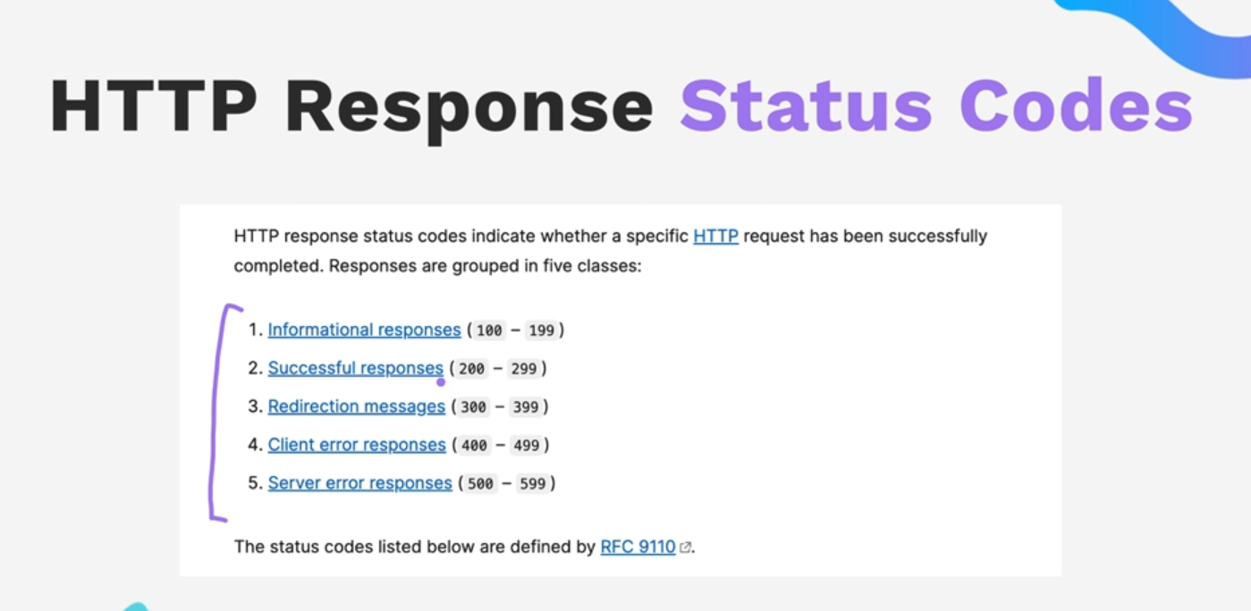

Public folder is usually the place where we put our static files
Making forms we usually use
For using res.sendFile method , You have to specify the entire directory name “Windows:User:admin:…..”
That’s why we do __dirname +
The middlewares parse the raw requests before its sent for get,post methods to handle
They might be used to authenticate , before server starts working
+++++Express JS
app.get(“./”,(req,res)=>{
res.sendFile(
})
Why ise

